SecureFlex Fixed Deposit Account
KBZ Bank introduces SecureFlex Fixed Deposit Account – a Flexible Fixed Deposit product, which deviates from the traditional fixed deposit model. The SecureFlex Account will consist of two linked accounts designed to provide both flexibility and security for depositors. The Main Account will hold the locked deposit amount that earns a predefined highest interest rate. Secondary Account will hold the defined emergency deposit amount that earns a different interest rate and will allow redemptions over the period.

Opening an Account
The following types of SecureFlex Fixed Deposit Accounts can be opened:
. Individual Account
. Joint Account

High-Interest rate
Main Account:
70% of your total savings will be placed in a Fixed Deposit Account, allowing you to enjoy the highest available interest rates.
Secondary Account:
The remaining 30% will be held in a Savings Account, offering both flexibility and attractive interest rates.

Deposit
Minimum initial deposit: 1,000,000 MMK

Convenient Withdrawal
– Ability to make withdrawal from Secondary Account
– Ability to get interest upon withdrawal amount, also from remaining amount

Terms of deposit and interests
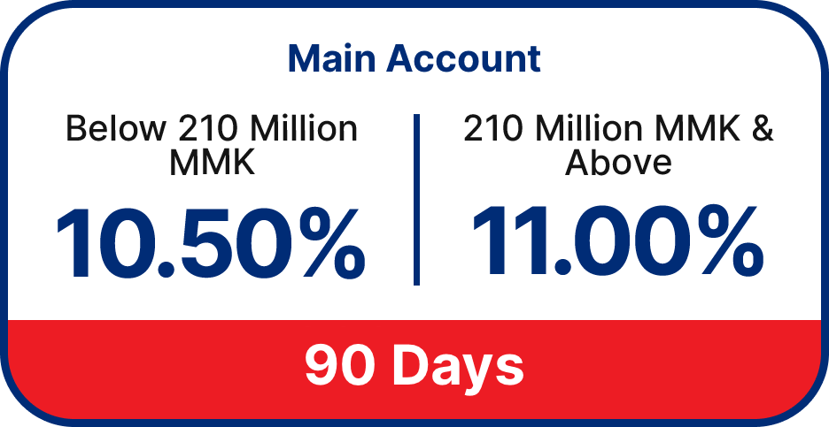
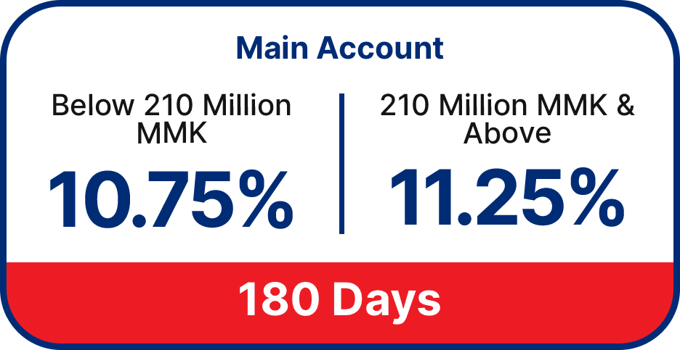
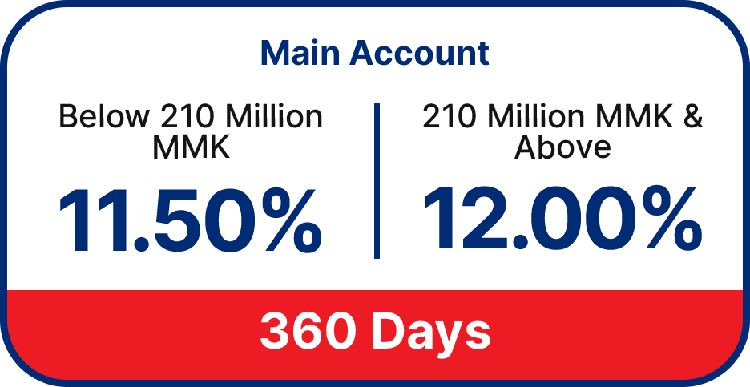
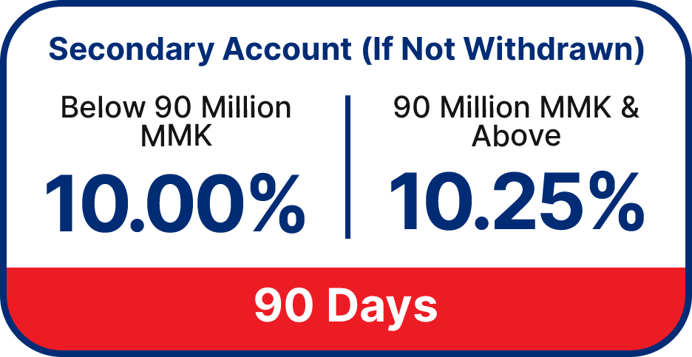
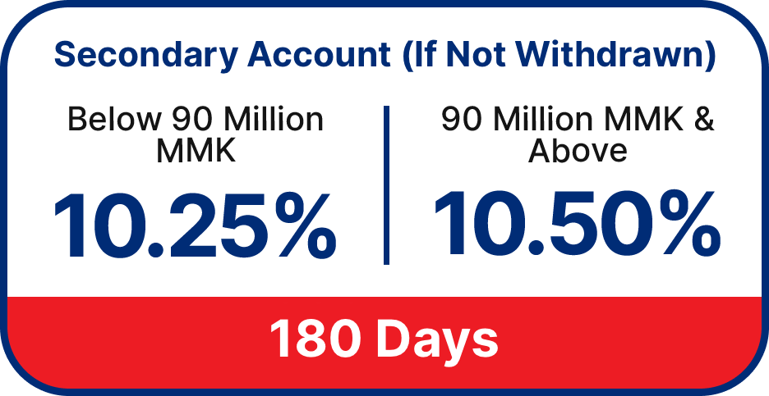
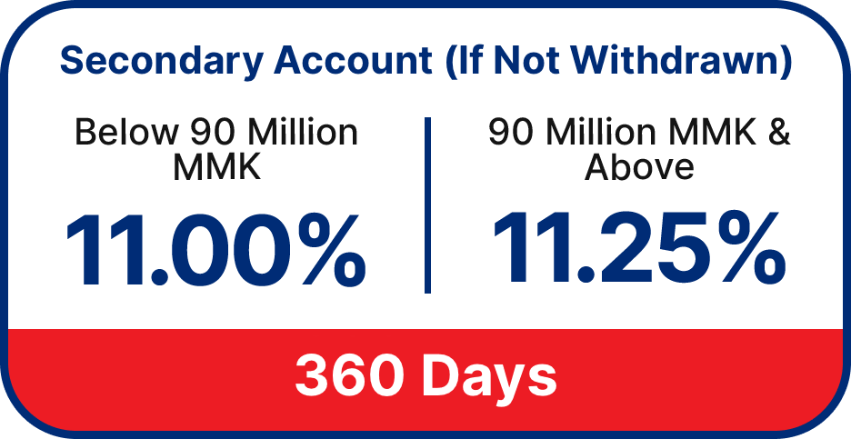
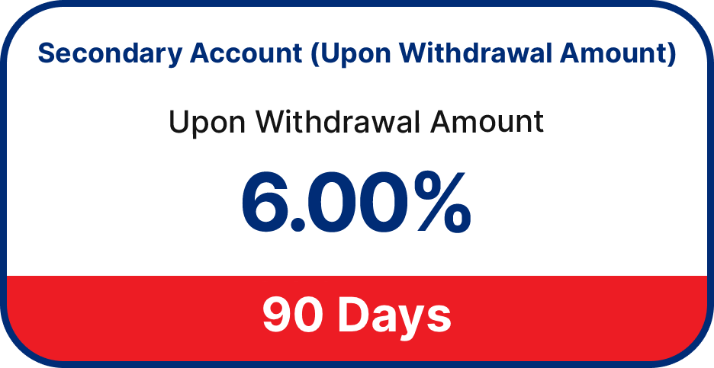
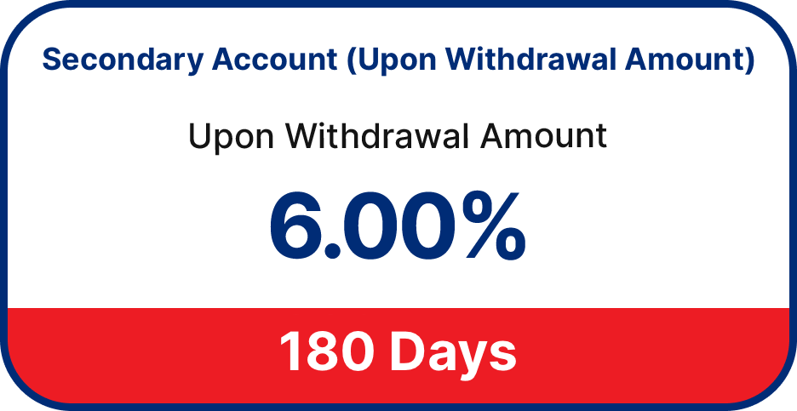
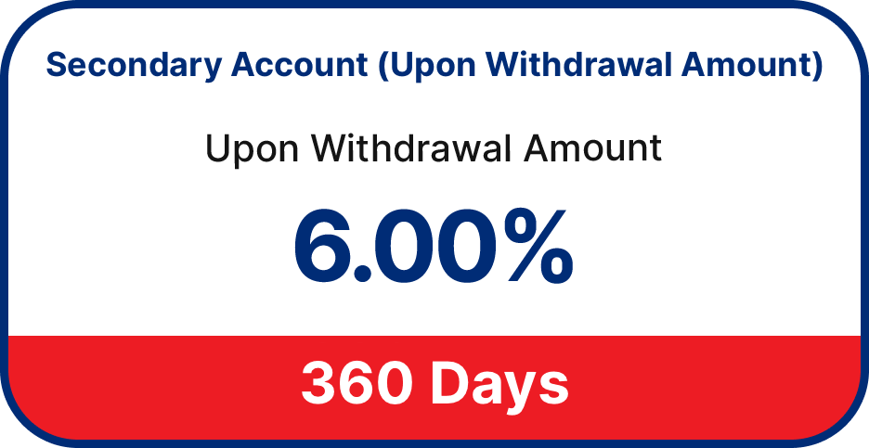

Primary Benefits
High Interest Rate
Save more and enjoy a high interest rate on a fixed amount. There is also interest on the withdrawal amount and no interest loss for the customer.

Flexibility
Can make withdrawal from secondary account if there is in case of emergencies.

Applying Loan Against Fixed Deposit
Need urgent cash? You can apply for an instant loan using your Fixed Deposit (FD) as collateral via i/mBanking. Applications are accepted up to 3 days before your FD matures.
– Minimum Fixed Deposit Balance: 6,250,000 MMK
– Account Type: Individual FD accounts only
– Minimum Loan Amount: 5,000,000 MMK
– Maximum Loan Limit: Up to 80% of your FD balance (available in up to 2 applications)

